Instituto de Tecnologia e Liderança

**Public Report**

**Students**: Kathlyn Diwan, Matheus Fidelis dos Santos, Mateus Almeida PintoRodrigo Moraes Martins, Stefano Tosi Butori

**Advisor**: Prof. José Romualdo

São Paulo, 2025.

**Summary**

1. Introduction/Executive Summary................................................3
2. Market Analysis and Gap......................................................... 4
3. Enterprise Description............................................................ 5
4. **Business Model and Value Proposition**.................................... 6
5. Financial Analysis................................................................8
6. Personas and Market Validation............................................. 9
7. Roadmap and Timeline........................................................10
8. Success Metrics and KPIs.................................................... 11
9. References......................................................................... 12

**1. Introduction/Executive Summary**

This document consolidates the development of an innovative PropTech aimed at revolutionizing the Brazilian real estate market through the adaptation of the French Viager model, enhanced by Artificial Intelligence technology. The project seeks to address structural challenges in the sector by offering more flexible and efficient financing alternatives.

The central problem addressed is the rigidity of the Brazilian real estate market, characterized by high interest rates (Selic projected at 15% for 2025) and a mismatch between the needs of different generations: elderly with underutilized properties seeking supplementary income, and young people facing barriers to property acquisition.

Demographic data reinforces the opportunity: by 2070, 37.8% of the Brazilian population will be over 60 (IBGE), while the fertility rate is expected to drop to 1.53 children per woman in 2025. Meanwhile, 43% of Brazilians plan to buy property, with special focus on the 16-34 age group.

The main objective is to develop a platform that:

* Adapts the French Viager model to the Brazilian context
* Automates legal and contractual analyses through AI
* Connects elderly sellers with young buyers
* Reduces operational costs and bureaucracy

**2. Market Analysis and Gap**

The Brazilian real estate market faces structural challenges exacerbated by macroeconomic pressures and significant demographic changes.

**2.1. Identified Challenges**

Rigidity and Bureaucracy

- High costs with interest rates (Selic) projected at 15% for 2025

- Bureaucratic processes hindering asset monetization for the elderly

- Entry barriers for young buyers

Demographic Pressures

- Rapidly aging population (37.8% above 60 by 2070)

- Fertility rate dropping to 1.53 children per woman

- Pent-up demand: 43% of Brazilians plan to buy properties

Operational Inefficiencies

- Slow and costly legal analyses

- Lack of automation in repetitive processes

- Operational costs 15-20% higher due to delays

**2.2. Economic Context**

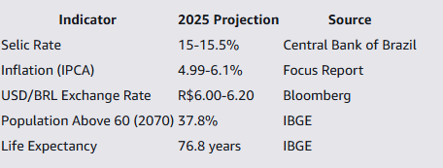

**3. Enterprise Description**

Our PropTech revolutionizes the Brazilian real estate market by combining advanced technology with innovative business models. The platform operates on two main fronts:

3.1. Innovation in Real Estate Contracts

- Adaptation of the French Viager model to the Brazilian context

- Implementation of reverse mortgage solutions

- Automation and acceleration of contractual processes

**3.2. AI-Driven Solutions**

- AI-powered contract management platform

- Analysis and automation of judicial processes

- Scalable solutions for real estate companies, brokers, and investors

**3.3. Target Audience**

Our solution serves multiple stakeholders in the real estate sector:

- Real estate companies and brokers

- Investors

- Property owners (especially elderly)

- Young buyers seeking financing alternatives

- Law firms specializing in real estate law

**4. Business Model and Value Proposition**

**4.1. Value Proposition**

Our startup presents an innovative solution to structural challenges in the Brazilian real estate market by combining:

- For Seniors:

* - Secure mechanism for monetizing real estate assets
* - Lifetime income guarantee
* - Property usage rights maintenance
* - Fraud-proof contracts through AI verification
* - For Young Buyers:
* - Alternative financing options
* - Lower initial investment requirements
* - Reduced bureaucracy
* - AI-powered matching system

- For the Real Estate Ecosystem:

* - 80% reduction in transaction time
* - Automated legal analysis with 80% accuracy
* - Reduced risk of legal inconsistencies
* - Scalable technology platform

**4.2. Product Portfolio Development Timeline**

Phase 1 - Year 1 (Validation and MVP)

- Q1-Q2:

- Market research and validation

- Pilot partnerships with real estate agencies

- Core AI Agent development for document analysis

- Q3-Q4:

- MVP launch with essential features

- Lifetime income simulator

- Buyer-seller matching module

Phase 2 - Year 2 (Controlled Scaling)

- Integration with public sector systems

- Hybrid financing models introduction

- Expansion to 1-2 cities with high senior concentration

Phase 3 - Year 3+ (Consolidation)

- Platform-as-a-Service offering

- Predictive property pricing system

- Financial institution partnerships

**5. Financial Analysis**

**5.1. Cost Structure Comparison**

Initial Investment Comparison

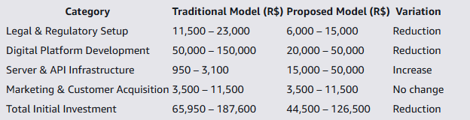

**5.2. Revenue Structure**

**Transaction Revenue Model**

Based on FipeZAP Index data for December 2024:

- Average property price per square meter: R$ 9,366

- Average property size: 70 m²

- Average property value: R$ 655,620

**Revenue Components:**

1. Initial Payment (Bouquet)

- 20% of property value: R$ 131,124

- Company commission: 1%

2. Monthly Payments

- Remaining value: R$ 524,496

- Monthly rate: 0.5%

- Monthly payment: R$ 2,622.48

3. Administration Fee

- 1% of property value: R$ 6,556.20 monthly

- Total monthly revenue per contract: R$ 9,178.68

**5.3. Profitability Analysis**

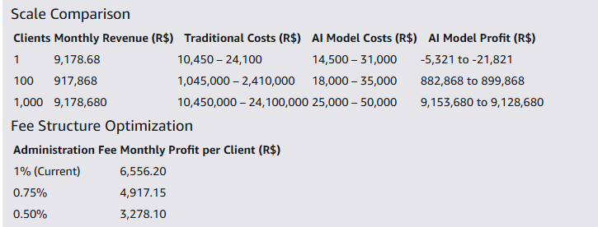

**6. Personas and Market Validation**

Our market research identified three key personas:

**6.1. Senior Homeowner**

**Carlos Silva, 72**

- Retired history teacher

- Owns property but needs additional income

- Concerned about maintaining living rights

- Seeks financial security

**6.2. Young Professional**

**Estela Morro, 29**

- Marketing analyst

- Seeking property investment

- Limited initial capital

- Open to alternative financing

**6.3. Institutional Partner**

**CrediSenior S.A.**

- Financial institution

- Focus on innovative products

- Regulatory compliance priority

- Risk management expertise

**7. Roadmap and Timeline**

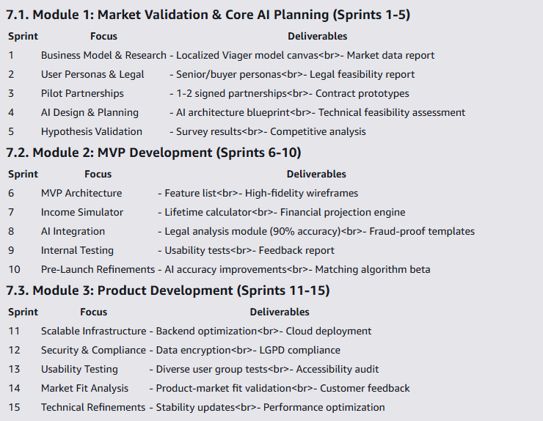

**8. Success Metrics and KPIs**

**8.1. Business Metrics**

- Number of active users

- Number of active institutions

- Volume of transactions

- Customer satisfaction rates

**8.2. Technical Performance**

- Platform availability: >99.5%

- Mean Time to Recovery: <2 hours

- API response time: <300ms

- Code coverage: >70%

**8.3. Financial Targets**

Year 1:

- Process 10-20 contracts

- Maintain development costs below R$400,000

- Achieve 85% platform uptime

Year 2:

- Break-even achievement

- Reduce administration fees to 0.75%

- Scale to 100+ active contracts

**8.4. Social Impact**

- Enable 2-3 pilot transactions for seniors

- Document 4-10% cost reduction vs traditional methods

- Improve access to housing for young professionals

**9. References**

Connexion France. (n.d.). Buying and selling a home in France: What is the viager system? Connexion France. https://www.connexionfrance.com/practical/buying-and-selling-a-home-in-france-what-is-the-viager-system/590575

Auction House. (n.d.). Auction House website. Auction House. https://www.auctionhouse.co.uk/

Banco Central do Brasil. (n.d.). Official website of the Central Bank of Brazil. Banco Central do Brasil. https://www.bcb.gov.br/

PagSeguro. (n.d.). Taxa Selic: O que é e como afeta seus investimentos? PagSeguro Blog. https://blog.pagseguro.uol.com.br/taxa-selic/

Olhar Digital. (2025, January 1). Nova cara do Brasil em 2025: Mais idosos, menos crianças e vida mais longa. Olhar Digital. https://olhardigital.com.br/2025/01/01/medicina-e-saude/nova-cara-do-brasil-em-2025-mais-idosos-menos-criancas-e-vida-mais-longa/

InfoMoney. (n.d.). O que esperar do câmbio, inflação e Selic em 2025? InfoMoney. https://www.infomoney.com.br/economia/o-que-esperar-do-cambio-inflacao-e-selic-em-2025/

ABECIP. (n.d.). Fraudes imobiliárias: Dicas para reconhecer e se proteger durante negociações de imóveis. ABECIP. https://www.abecip.org.br/imprensa/noticias/fraudes-imobiliarias-dicas-para-reconhecer-e-se-proteger-durante-negociacoes-de-imoveis-exame